Project Design Phase-II
Data Flow Diagram & User Stories

Date | 03-10-2026
Team ID | SWTID-2026-8713
Project Name | Implement Client Script & UI Policy (Incident)
Maximum Marks | 4 Marks
Data Flow Diagrams:
A Data Flow Diagram (DFD) is a traditional visual representation of the information flows within a system. A neat and clear DFD can depict the right amount of the system requirement graphically. It shows how data enters and leaves the system, what changes the information, and where data is stored.
Example: DFD Level 0 – Client Scripts and UI Policies
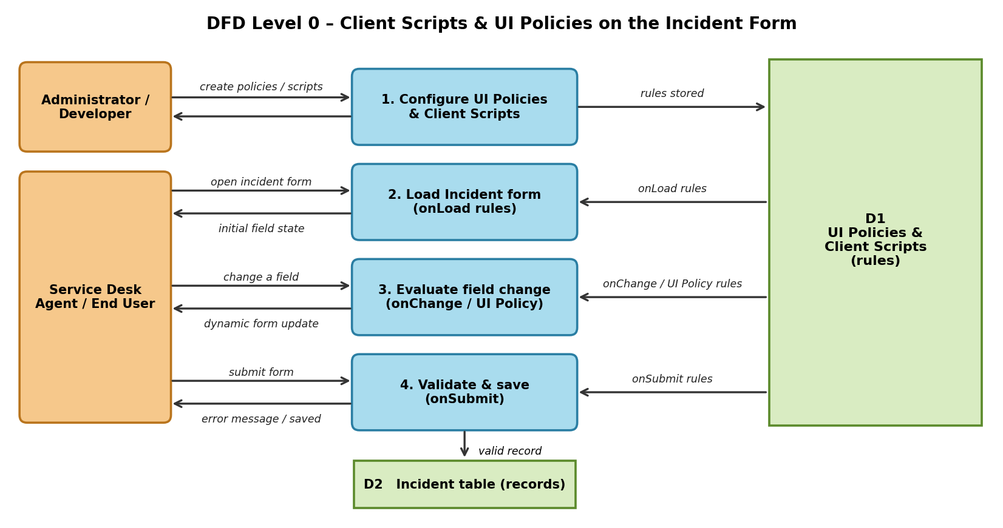
Flow
- The Administrator / Developer creates the UI Policies and Client Scripts for the Incident form (Process 1, stored in D1).
- A service desk agent / end user opens the Incident form.
- The onLoad Client Scripts and UI Policies are read from D1 and set the initial field state (Process 2).
- When the agent changes a field, the onChange Client Scripts and UI Policy conditions are evaluated (Process 3) and the form is updated immediately: fields are shown, hidden, made mandatory or read-only, and messages are displayed.
- When the agent submits, the onSubmit Client Script validates the data (Process 4). If the data is invalid, a message is shown and the save is stopped.
- If the data is valid, the incident is saved in the Incident table (D2).
User Stories
Use the below template to list all the user stories for the product.
User Type | Functional  Requirement  (Epic) | User  Story  Number | User Story / Task | Acceptance criteria | Priority | Release
Developer | UI Policy –  Mandatory  Fields | USN-1 | As a developer, I can create  a UI policy that makes  Close code and Close notes  mandatory when State is  Resolved or Closed. | The fields become  mandatory on the form  as soon as State  changes, and the  incident cannot be  saved without them. | High | Sprint-1
 |  | USN-2 | As a developer, I can make  Short description mandatory  for every new incident. | A new incident cannot  be saved with an  empty Short  description. | High | Sprint-1
 | UI Policy –  Visibility and  Read-only | USN-3 | As a developer, I can show  or hide fields (for example,  On hold reason) based on  State and Category. | Fields appear or  disappear immediately  without reloading the  form. | High | Sprint-1
 |  | USN-4 | As a developer, I can make  fields read-only for closed  incidents. | Closed incidents  cannot be edited by  normal users. | Medium | Sprint-2
 | Client Script  – onLoad | USN-5 | As a developer, I can write  an onLoad Client Script that  sets the initial form state  and shows guidance. | The form opens with  the correct default  state and a helpful  message. | High | Sprint-2
 | Client Script  – onChange | USN-6 | As a developer, I can write  an onChange Client Script  on Category, State, Impact  or Urgency that updates  other fields. | Dependent fields  update correctly when  the source field  changes and not while  the form is loading. | High | Sprint-2
 | Client Script  – onSubmit | USN-7 | As a developer, I can write  an onSubmit Client Script  that validates the data  before save. | Invalid data shows a  clear message and the  save is blocked; valid  data is saved. | High | Sprint-2
 | Testing and  Verification | USN-8 | As a developer, I can test  every rule by changing  fields on the form and  checking the browser  console. | Results are checked  for each State and  field, and script errors  can be traced. | Medium | Sprint-3
Service Desk  Agent / End  User | Form  Guidance | USN-9 | As a service desk agent, I  see only the fields that  matter for the current State  and Category. | The form is shorter and  easier to read, with  mandatory fields  clearly marked. | High | Sprint-2
 |  | USN-10 | As an agent, I get a clear  message when I enter  incorrect or inconsistent  data. | A field message or  alert explains what to  correct before I save. | High | Sprint-2
Administrator | Rule  Maintenance | USN-11 | As an administrator, I can  activate, deactivate and  update the Client Scripts  and UI Policies. | Changes take effect on  the form without  changing other  configuration. | Medium | Sprint-3

